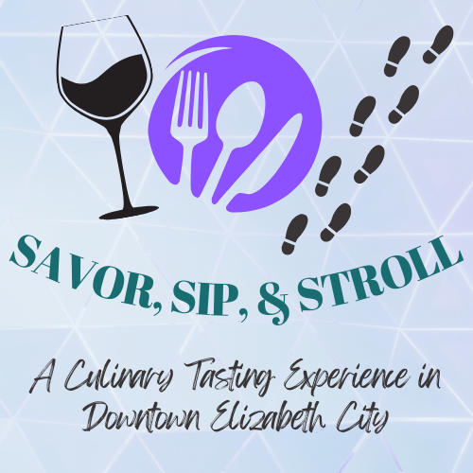
A Culinary Tasting Event in Downtown Elizabeth City
Thursday, March 5th, 2026

“Savor, Sip, and Stroll” is a culinary “crawl” through downtown Elizabeth City. Ticketholders will visit participating restaurants, watering holes, and shops for a small sampling of food and/or beverages.
Tickets are $50 and will be limited to a maximum of 250 attendees.
Proceeds from the event will benefit Albemarle Hopeline, which serves victims and survivors of domestic and sexual violence in our community.

As a Participating “Stroll Stop,” You Will Receive:
- Up to 250 potential new customers to taste your venue’s fare- use this opportunity to spotlight your business and expand your brand recognition!

- Logo and link to your venue on the event website for attendees to learn more about your fare (they may just get so hungry they come visit you sooner!)

- Exposure through social media marketing.

- Disposables provided by the event (must pre-order by February 20th).

- Designated volunteers at your location during the event to guide traffic and help hand out samples.

- The opportunity to provide follow-up offers to attendees such as coupons or special discounts to entice them to return!

- Alignment with charitable works in the community – you will also receive a tax receipt for your contributions of food and labor.

You can still be open for regular business during the event, and entice attendees to stay for a drink or dessert!

Stroll Stop Participation
What We Ask of You:
- Provide a sample of food and/or drink for up to 250 attendees (headcount will be provided by the event 10 days prior but will not exceed 250 people).

Get creative and use this as an opportunity to really showcase your business! Do you want people to know that you have a great dessert menu or that you also cook a delicious brunch? You can also choose to partner with other local providers to feature their ingredients!

- Provide a separate table / space for guests to sample and linger.

- Permit sponsor signage at your location during the event.

- Help to promote the event through your own social media and signage at your location.

- Pre-order your disposables through Hopeline by February 20th .

- E-mail your logo to ccottrell@albemarlehopeline.org for use in event marketing.

Stroll Stop Commitment Form
Venue Name: _________________________________________________
Contact Name:_________________________________________________
Best Phone #: __________________________________________________
E-mail: ______________________________________________________
Point of Contact During the Event : ____________________________________________________________
Website: ______________________________________________________
Printed Name of Owner/Manager: ____________________________________
Signature: _____________________________________________________
Date: _____________________


Thank you for your support!

